Lesson 2 Homework | LT 1.1, 1.2, and 1.3 | 3-19 odd, 21-26, 28, 29  (draw picture for #21-26 and #28-29)
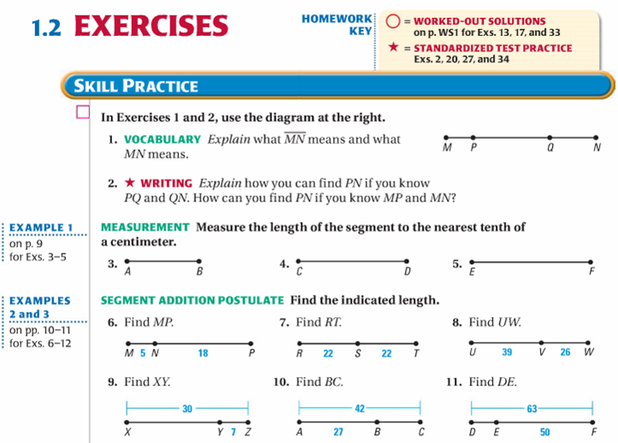

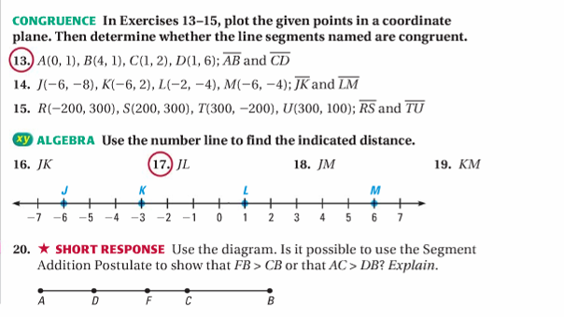

Lesson 2 Homework | LT 1.1, 1.2, and 1.3 | 3-19 odd, 21-26, 28, 29  (draw picture for #21-26 and #28-29)

